#### **Project details are available from page 13**

#### **1. ConfigMap**

**ConfigMap** is a Kubernetes object that lets you store configuration data in key-value pairs. It is used to manage non-sensitive configuration information separately from the application code.

**Creating a ConfigMap**

You can create a ConfigMap from a literal value or from a file. Here’s an example of creating a ConfigMap from literal values:

apiVersion: v1

kind: ConfigMap

metadata:

name: web-config

data:

DATABASE_URL: "jdbc:mysql://db-server:3306/mydatabase"

APP_ENV: "production"

**Using ConfigMap in a Pod**

To use the ConfigMap in a Pod, you need to reference it in your Pod specification. Here’s how you can inject ConfigMap values as environment variables:

apiVersion: v1

kind: Pod

metadata:

name: web-app

spec:

containers:

- name: web-container

image: my-web-app:latest

env:

- name: DATABASE_URL

valueFrom:

configMapKeyRef:

name: web-config

key: DATABASE_URL

- name: APP_ENV

valueFrom:

configMapKeyRef:

name: web-config

key: APP_ENV

**Example Use Case: Mounting ConfigMap as a File**

Sometimes, an application may require configuration files. You can mount a ConfigMap as a file inside a container.

apiVersion: v1

kind: ConfigMap

metadata:

name: config-files

data:

config.yaml: |

database:

url: "jdbc:mysql://db-server:3306/mydatabase"

environment: "production"

**Mount the ConfigMap as a volume in the Pod:**

apiVersion: v1

kind: Pod

metadata:

name: web-app

spec:

containers:

- name: web-container

image: my-web-app:latest

volumeMounts:

- name: config-volume

mountPath: /etc/config

volumes:

- name: config-volume

configMap:

name: config-files

The configuration file config.yaml will be available at /etc/config/config.yaml inside the container.

#### **2. Secrets**

**Secrets** is a Kubernetes object designed to hold sensitive data such as passwords, OAuth tokens, and SSH keys. Secrets ensure that sensitive information is stored securely.

**Creating a Secret**

You can create a Secret from literal values or from files. Here’s an example of creating a Secret from literal values:

apiVersion: v1

kind: Secret

metadata:

name: db-credentials

type: Opaque

data:

username: dXNlcm5hbWU= # base64 encoded 'username'

password: cGFzc3dvcmQ= # base64 encoded 'password'

**Using Secrets in a Pod**

To use the Secret in a Pod, reference it in your Pod specification and inject it as environment variables:

apiVersion: v1

kind: Pod

metadata:

name: web-app

spec:

containers:

- name: web-container

image: my-web-app:latest

env:

- name: DB_USERNAME

valueFrom:

secretKeyRef:

name: db-credentials

key: username

- name: DB_PASSWORD

valueFrom:

secretKeyRef:

name: db-credentials

key: password

**Example Use Case: Mounting Secrets as Files**

For applications that require secrets as files, you can mount the Secret as a volume inside a container.

apiVersion: v1

kind: Secret

metadata:

name: ssh-keys

type: Opaque

data:

ssh-privatekey: <base64-encoded-private-key>

ssh-publickey: <base64-encoded-public-key>

Mount the Secret as a volume in the Pod:

apiVersion: v1

kind: Pod

metadata:

name: web-app

spec:

containers:

- name: web-container

image: my-web-app:latest

volumeMounts:

- name: ssh-volume

mountPath: /etc/ssh

readOnly: true

volumes:

- name: ssh-volume

secret:

secretName: ssh-keys

The SSH keys will be available at /etc/ssh inside the container.

#### **3. Environment Variables**

Environment variables are a way to pass configuration settings to applications running inside containers. They can be defined directly in the Pod specification or sourced from ConfigMaps and Secrets.

**Example Use Case: Passing Configuration to a Container**

Environment variables can be used to pass various configurations like application mode, API endpoints, and feature flags to the container.

**Defining Environment Variables in Pod Specification**

apiVersion: v1

kind: Pod

metadata:

name: web-app

spec:

containers:

- name: web-container

image: my-web-app:latest

env:

- name: APP_MODE

value: "production"

- name: API_ENDPOINT

value: "https://api.example.com"

**Example Use Case: Using Environment Variables from ConfigMaps and Secrets**

Combining ConfigMaps and Secrets with environment variables provides a flexible and secure way to manage configurations.

**Using ConfigMap and Secret Environment Variables Together**

apiVersion: v1

kind: Pod

metadata:

name: web-app

spec:

containers:

- name: web-container

image: my-web-app:latest

env:

- name: DATABASE_URL

valueFrom:

configMapKeyRef:

name: web-config

key: DATABASE_URL

- name: APP_ENV

valueFrom:

configMapKeyRef:

name: web-config

key: APP_ENV

- name: DB_USERNAME

valueFrom:

secretKeyRef:

name: db-credentials

key: username

- name: DB_PASSWORD

valueFrom:

secretKeyRef:

name: db-credentials

key: password

**Autoscaling in Kubernetes**

### **1. Horizontal Pod Autoscaler (HPA)**

**1.1. Define a Deployment**

apiVersion: apps/v1

kind: Deployment

metadata:

name: web-app

spec:

replicas: 2

selector:

matchLabels:

app: web-app

template:

metadata:

labels:

app: web-app

spec:

containers:

- name: web-container

image: my-web-app:latest

ports:

- containerPort: 80

resources:

requests:

cpu: "500m"

limits:

cpu: "1"

**1.2. Apply the Deployment**

kubectl apply -f deployment.yaml

**1.3. Create a Service**

apiVersion: v1

kind: Service

metadata:

name: web-service

spec:

selector:

app: web-app

ports:

- protocol: TCP

port: 80

targetPort: 80

type: LoadBalancer

**1.4. Apply the Service**

kubectl apply -f service.yaml

**1.5. Create an HPA**

Define an HPA to scale the number of pods based on CPU utilization:

apiVersion: autoscaling/v2beta2

kind: HorizontalPodAutoscaler

metadata:

name: web-app-hpa

spec:

scaleTargetRef:

apiVersion: apps/v1

kind: Deployment

name: web-app

minReplicas: 2

maxReplicas: 10

metrics:

- type: Resource

resource:

name: cpu

target:

type: Utilization

averageUtilization: 50

**1.6. Apply the HPA**

kubectl apply -f hpa.yaml

### **Vertical Pod Autoscaler (VPA)**

**2.1. Define a Deployment**

Create a Deployment for the batch job:

apiVersion: apps/v1

kind: Deployment

metadata:

name: batch-job

spec:

replicas: 1

selector:

matchLabels:

app: batch-job

template:

metadata:

labels:

app: batch-job

spec:

containers:

- name: batch-container

image: my-batch-job:latest

resources:

requests:

cpu: "500m"

memory: "1Gi"

limits:

cpu: "1"

memory: "2Gi"

**2.2. Apply the Deployment**

kubectl apply -f deployment.yaml

**2.3. Create a VPA**

Define a VPA to manage the resource requests and limits for the Pod:

apiVersion: verticalpodautoscaler.k8s.io/v1

kind: VerticalPodAutoscaler

metadata:

name: batch-job-vpa

spec:

targetRef:

apiVersion: apps/v1

kind: Deployment

name: batch-job

updatePolicy:

updateMode: Auto

**2.4. Apply the VPA**

kubectl apply -f vpa.yaml

**Linux Scripts**

### **Viewing Processes (ps, top)**

#### **Use Cases:**

1. **System Monitoring**:
   * **Example**: An administrator needs to check the status of all running processes to ensure that critical applications are running smoothly.

**Commands**:  
  
ps aux # Displays detailed information about all running processes

top # Interactive view of system processes, updates in real time

1. **Troubleshooting Performance Issues**:
   * **Example**: A developer notices that the server is slow and needs to find out which processes are consuming the most CPU or memory.

**Commands**:  
  
top # Look for processes consuming high CPU or memory

ps -eo pid,comm,%cpu,%mem --sort=-%cpu | head # Display top 10 processes by CPU usage

1. **Identifying Zombie Processes**:
   * **Example**: The system administrator is dealing with processes that are stuck in the “zombie” state.

**Commands**:  
  
ps aux | grep 'Z' # Finds processes in a zombie state

#### **Examples:**

**Example 1**:  
  
ps aux | grep nginx

* Finds processes related to the nginx web server.

**Example 2**:  
  
top -u username

* Displays processes owned by a specific user.

### **Managing Processes (kill, nice)**

#### **Use Cases:**

1. **Stopping Unresponsive Applications**:
   * **Example**: A user needs to stop a process that has become unresponsive or is consuming excessive resources.

**Commands**:  
  
kill -9 12345 # Forcefully terminates the process with PID 12345

1. **Adjusting Process Priority**:
   * **Example**: A system administrator wants to lower the priority of a process to ensure it does not hog resources.

**Commands**:  
  
nice -n 10 command # Start a process with a lower priority

renice +10 -p 12345 # Change the priority of an existing process with PID 12345

1. **Gracefully Stopping Services**:
   * **Example**: An admin needs to restart a service to apply configuration changes.

**Commands**:  
  
kill -HUP 12345 # Sends a SIGHUP signal to the process to reload configuration

#### **Examples:**

**Example 1**:  
  
killall -9 firefox

* Kills all processes named firefox.

**Example 2**:  
  
nice -n -10 ./heavy_script.sh

* Runs heavy_script.sh with a higher priority.

### **Configure SSH**

### **Shell Scripts**

#### **Writing Basic Shell Scripts**

##### **Use Cases:**

1. **Automating Routine Tasks**:
   * **Example**: A sysadmin wants to automate the backup of log files.

**Commands**:  
  
#!/bin/bash

cp /var/log/syslog /backup/syslog-$(date +%F).log

1. **System Maintenance**:
   * **Example**: A developer creates a script to clean up temporary files.

**Commands**:  
  
#!/bin/bash

rm -rf /tmp/*

1. **Batch Processing**:
   * **Example**: A data analyst needs to process multiple files in a directory.

**Commands**:  
  
#!/bin/bash

process_file() {

local file="$1"

echo "Processing $file"

# Add more commands to process the file here

}

for file in /data/*.csv; do

process_file "$file"

done

**Project 01**

In this project, you will develop a simple Node.js application, deploy it on a local Kubernetes cluster using Minikube, and configure various Kubernetes features. The project includes Git version control practices, creating and managing branches, and performing rebases. Additionally, you will work with ConfigMaps, Secrets, environment variables, and set up vertical and horizontal pod autoscaling.

## **Project 01**

## **Project Steps**

### **1. Setup Minikube and Git Repository**

**Start Minikube**:  
  
minikube start

#### **1.2 Set Up Git Repository**

**Create a new directory for your project**:  
  
mkdir nodejs-k8s-project

cd nodejs-k8s-project

**Initialize Git repository**:  
  
git init

**Create a .gitignore file**:  
  
node_modules/

.env

**Add and commit initial changes**:  
  
git add .

git commit -m "Initial commit"

### **2. Develop a Node.js Application**

#### **2.1 Create the Node.js App**

**Initialize the Node.js project**:  
  
npm init -y

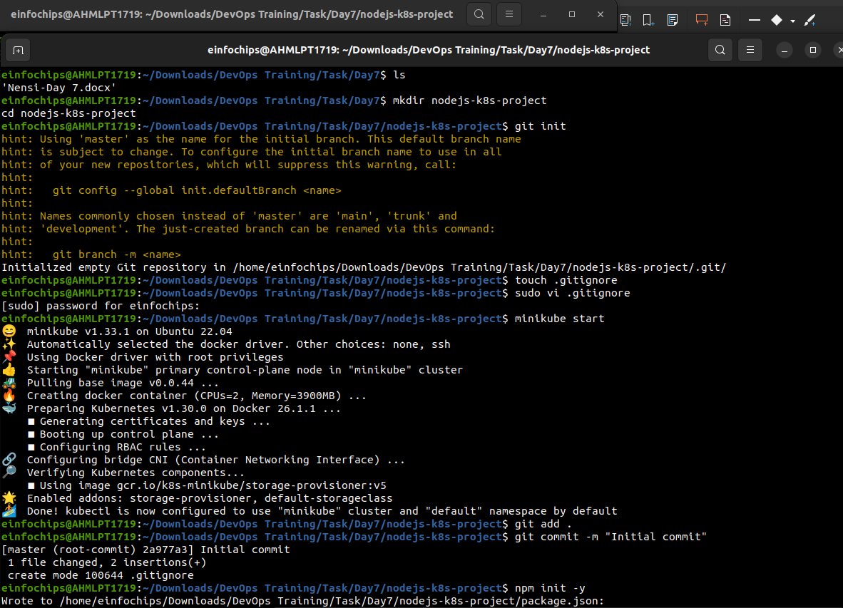

**Install necessary packages**:  
  
npm install express body-parser

**Create app.js**:  
  
const express = require('express');

const bodyParser = require('body-parser');

const app = express();

const PORT = process.env.PORT || 3000;

app.use(bodyParser.json());

app.get('/', (req, res) => {

res.send('Hello, World!');

});

app.listen(PORT, () => {

console.log(`Server is running on port ${PORT}`);

});

**Update package.json** to include a start script:  
  
"scripts": {

"start": "node app.js"

}

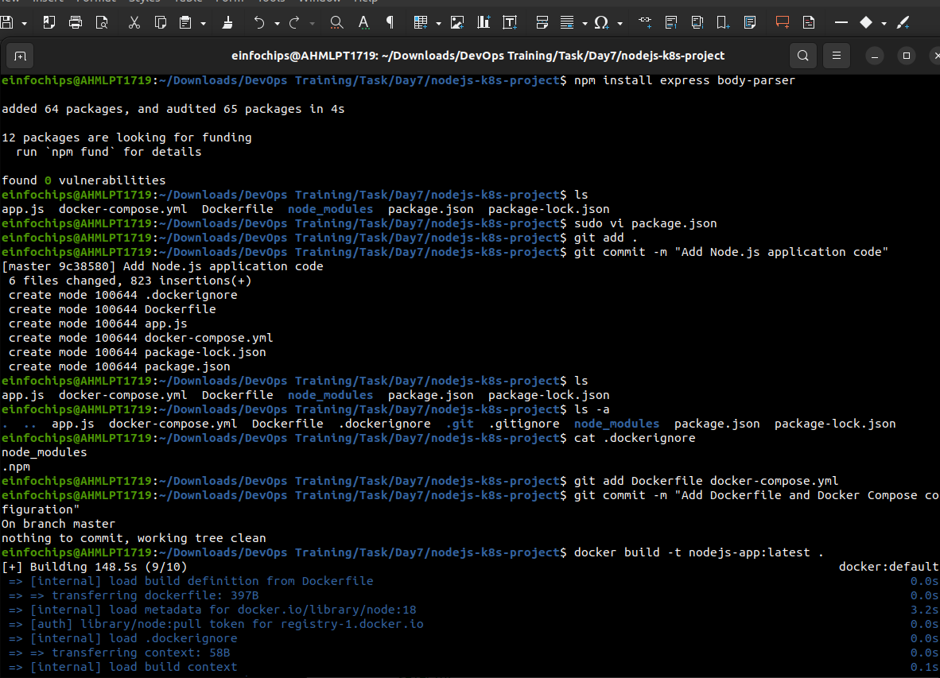

#### **2.2 Commit the Node.js Application**

**Add and commit changes**:  
  
git add .

git commit -m "Add Node.js application code"

### **3. Create Dockerfile and Docker Compose**

#### **3.1 Create a Dockerfile**

**Add Dockerfile**:  
  
# Use official Node.js image

FROM node:18

# Set the working directory

WORKDIR /usr/src/app

# Copy package.json and package-lock.json

COPY package*.json ./

# Install dependencies

RUN npm install

# Copy the rest of the application code

COPY . .

# Expose the port on which the app runs

EXPOSE 3000

# Command to run the application

CMD [ "npm", "start" ]

**Create a .dockerignore file**:  
  
node_modules

.npm

#### **3.2 Create docker-compose.yml (optional for local testing)**

**Add docker-compose.yml**:  
  
version: '3'

services:

app:

build: .

ports:

- "3000:3000"

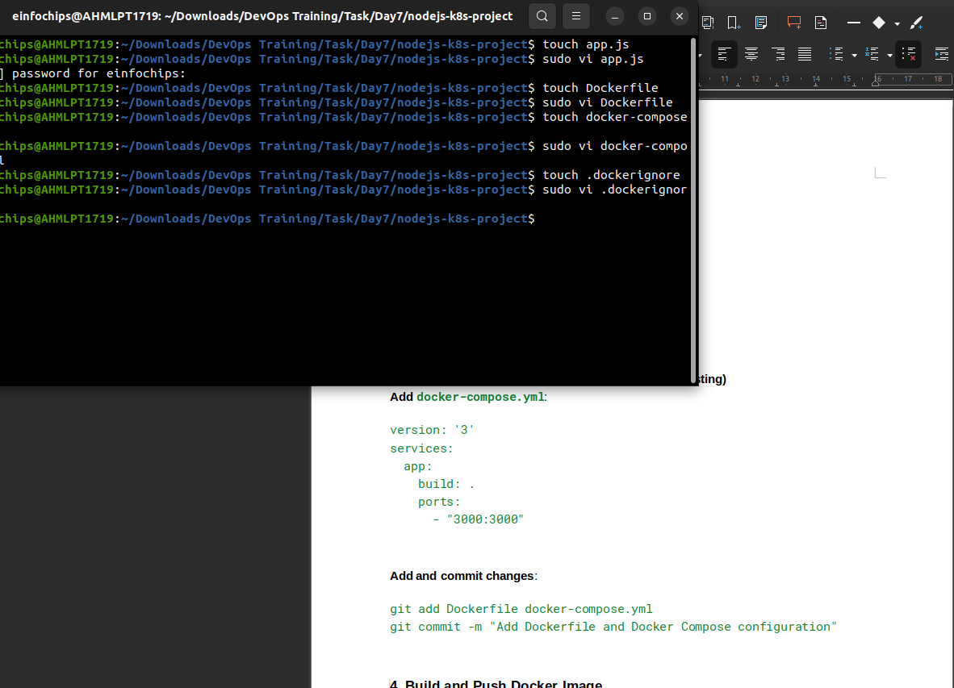

**Add and commit changes**:  
  
git add Dockerfile docker-compose.yml

git commit -m "Add Dockerfile and Docker Compose configuration"

### **4. Build and Push Docker Image**

#### **4.1 Build Docker Image**

**Build the Docker image**:  
  
docker build -t nodejs-app:latest .

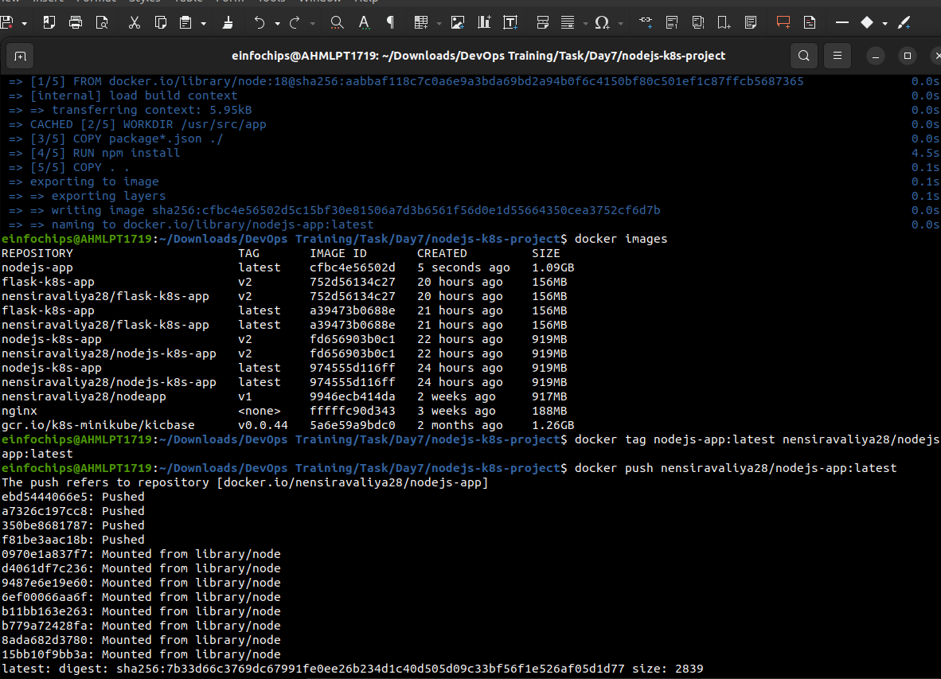

#### **4.2 Push Docker Image to Docker Hub**

**Tag and push the image**:  
  
docker tag nodejs-app:latest your-dockerhub-username/nodejs-app:latest

docker push your-dockerhub-username/nodejs-app:latest

**Add and commit changes**:  
  
git add .

git commit -m "Build and push Docker image"

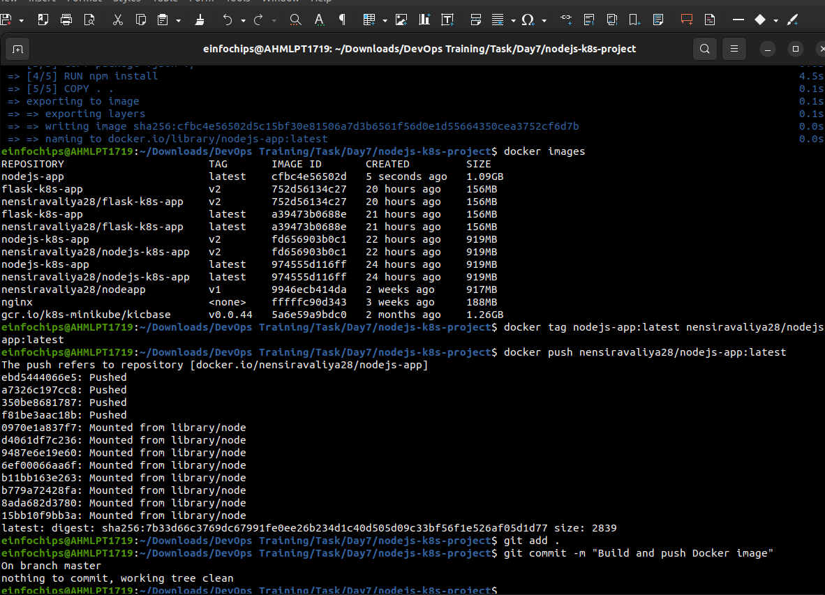

### **5. Create Kubernetes Configurations**

#### **5.1 Create Kubernetes Deployment**

**Create kubernetes/deployment.yaml**:

apiVersion: apps/v1

kind: Deployment

metadata:

name: nodejs-app-deployment

spec:

replicas: 2

selector:

matchLabels:

app: nodejs-app

template:

metadata:

labels:

app: nodejs-app

spec:

containers:

- name: nodejs-app

image: your-dockerhub-username/nodejs-app:latest

ports:

- containerPort: 3000

env:

- name: PORT

valueFrom:

configMapKeyRef:

name: app-config

key: PORT

- name: NODE_ENV

valueFrom:

secretKeyRef:

name: app-secrets

key: NODE_ENV

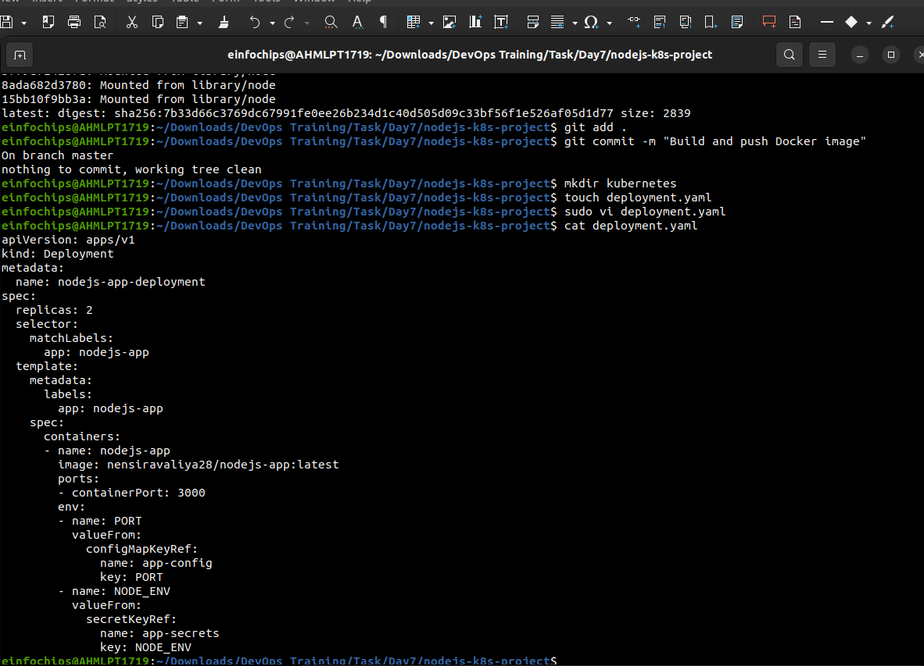

#### **5.2 Create ConfigMap and Secret**

**Create kubernetes/configmap.yaml**:  
  
apiVersion: v1

kind: ConfigMap

metadata:

name: app-config

data:

PORT: "3000"

**Create kubernetes/secret.yaml**:  
  
apiVersion: v1

kind: Secret

metadata:

name: app-secrets

type: Opaque

data:

NODE_ENV: cHJvZHVjdGlvbmFs # Base64 encoded value for "production"

**Add and commit Kubernetes configurations**:  
  
git add kubernetes/

git commit -m "Add Kubernetes deployment, configmap, and secret"

#### **5.3 Apply Kubernetes Configurations**

**Apply the ConfigMap and Secret**:  
  
kubectl apply -f kubernetes/configmap.yaml

kubectl apply -f kubernetes/secret.yaml

**Apply the Deployment**:  
  
kubectl apply -f kubernetes/deployment.yaml

### **6. Implement Autoscaling**

#### **6.1 Create Horizontal Pod Autoscaler**

**Create kubernetes/hpa.yaml**:  
  
apiVersion: autoscaling/v2beta2

kind: HorizontalPodAutoscaler

metadata:

name: nodejs-app-hpa

spec:

scaleTargetRef:

apiVersion: apps/v1

kind: Deployment

name: nodejs-app-deployment

minReplicas: 2

maxReplicas: 5

metrics:

- type: Resource

resource:

name: cpu

target:

type: Utilization

averageUtilization: 50

**Apply the HPA**:  
  
kubectl apply -f kubernetes/hpa.yaml

#### **6.2 Create Vertical Pod Autoscaler**

**Create kubernetes/vpa.yaml**:  
  
apiVersion: autoscaling.k8s.io/v1beta2

kind: VerticalPodAutoscaler

metadata:

name: nodejs-app-vpa

spec:

targetRef:

apiVersion: apps/v1

kind: Deployment

name: nodejs-app-deployment

updatePolicy:

updateMode: "Auto"

**Apply the VPA**:  
  
kubectl apply -f kubernetes/vpa.yaml

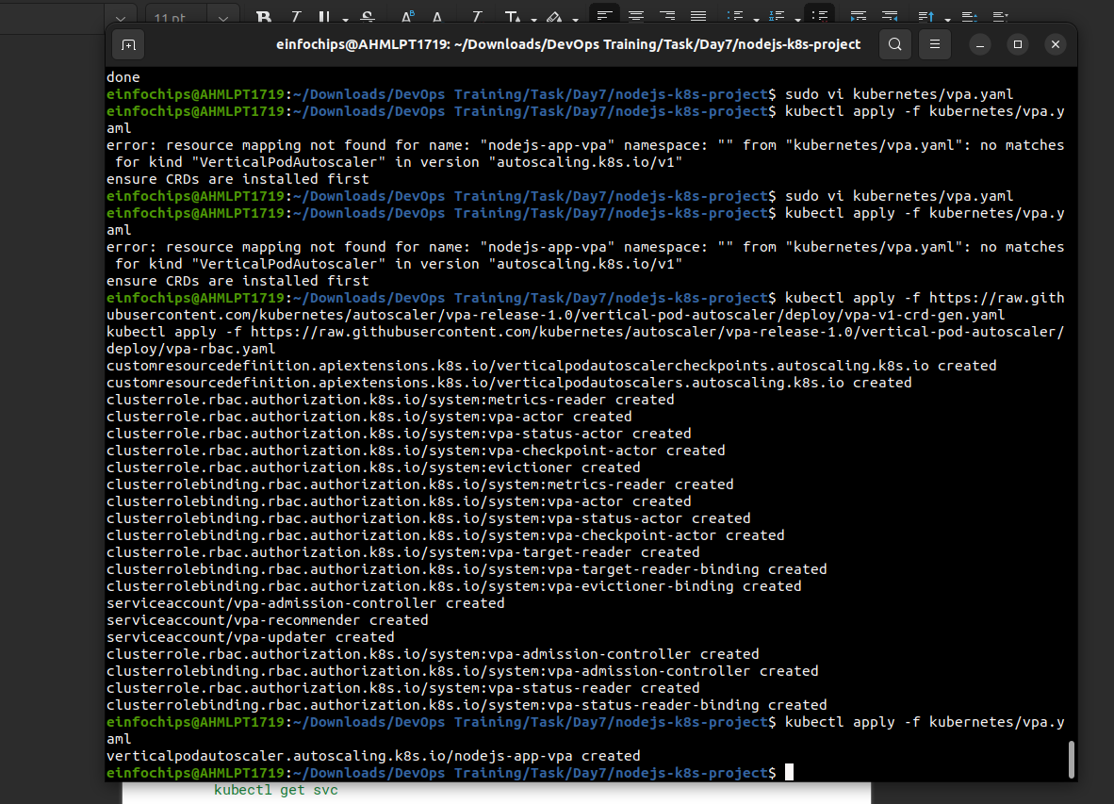

### **7. Test the Deployment**

#### **7.1 Check the Status of Pods, Services, and HPA**

**Verify the Pods**:  
  
kubectl get pods

**Verify the Services**:  
  
kubectl get svc

**Verify the HPA**:  
  
kubectl get hpa

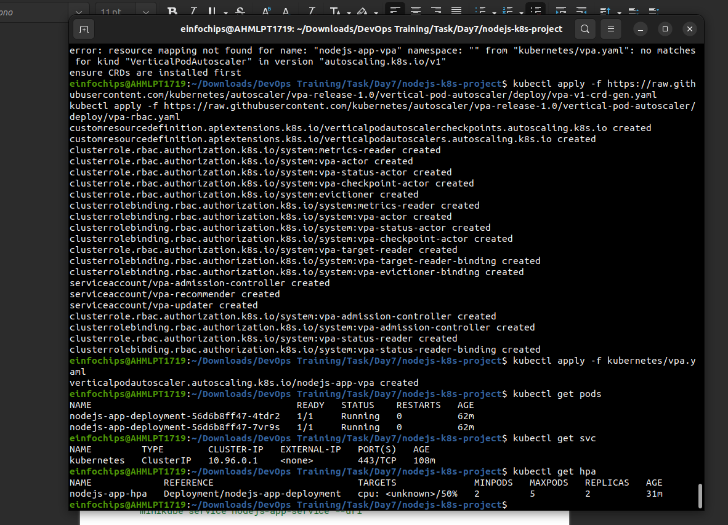

#### **7.2 Access the Application**

**Expose the Service**:  
  
kubectl expose deployment nodejs-app-deployment --type=NodePort --name=nodejs-app-service

**Get the Minikube IP and Service Port**:  
  
minikube service nodejs-app-service –url

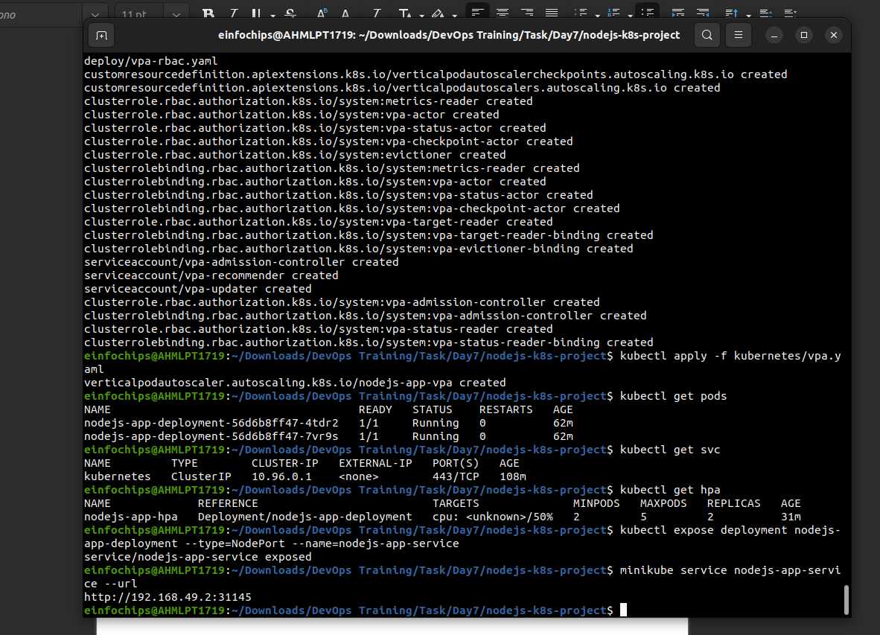

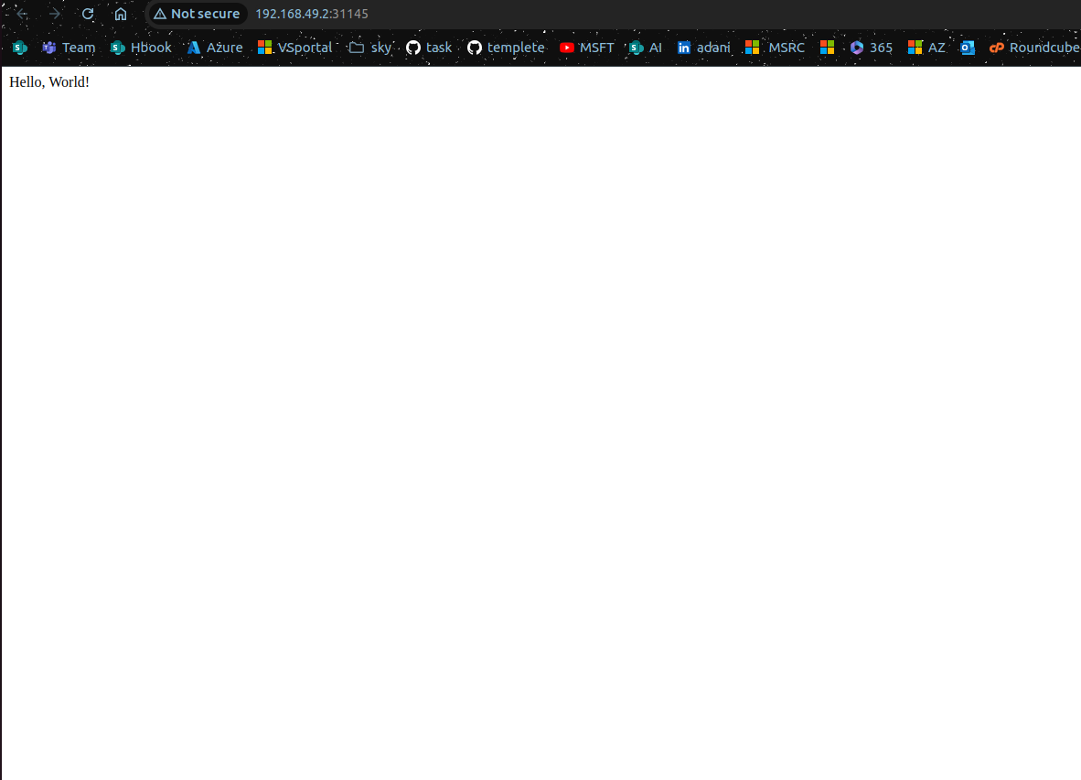**Access the Application** in your browser using the URL obtained from the previous command.

### **8. Git Version Control**

#### **8.1 Create a New Branch for New Features**

**Create and switch to a new branch**:  
  
git checkout -b feature/new-feature

**Make changes and commit**:  
  
# Make some changes

git add .

git commit -m "Add new feature"

**Push the branch to the remote repository**:  
  
git push origin feature/new-feature

#### **8.2 Rebase Feature Branch on Main Branch**

**Switch to the main branch and pull the latest changes**:  
  
git checkout main

git pull origin main

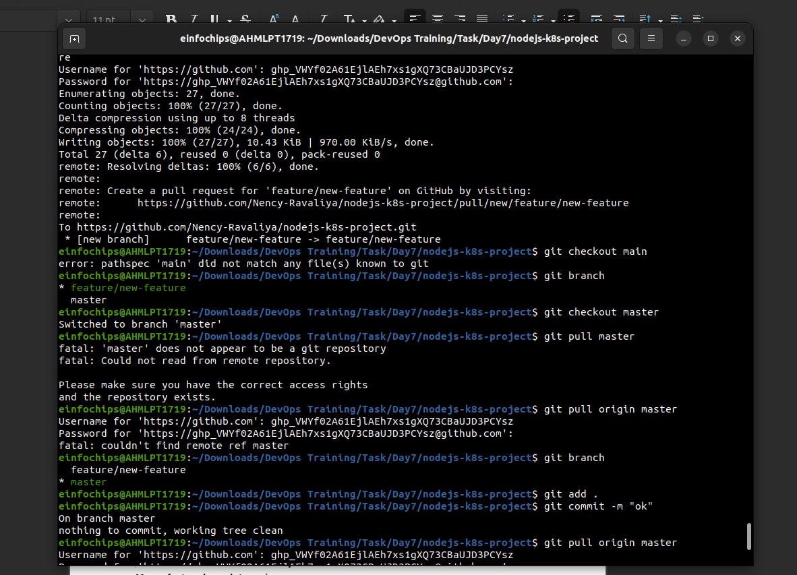

**Rebase the feature branch**:  
  
git checkout feature/new-feature

git rebase main

**Resolve conflicts if any, and continue the rebase**:  
  
git add .

git rebase --continue

**Push the rebased feature branch**:  
  
git push origin feature/new-feature –force

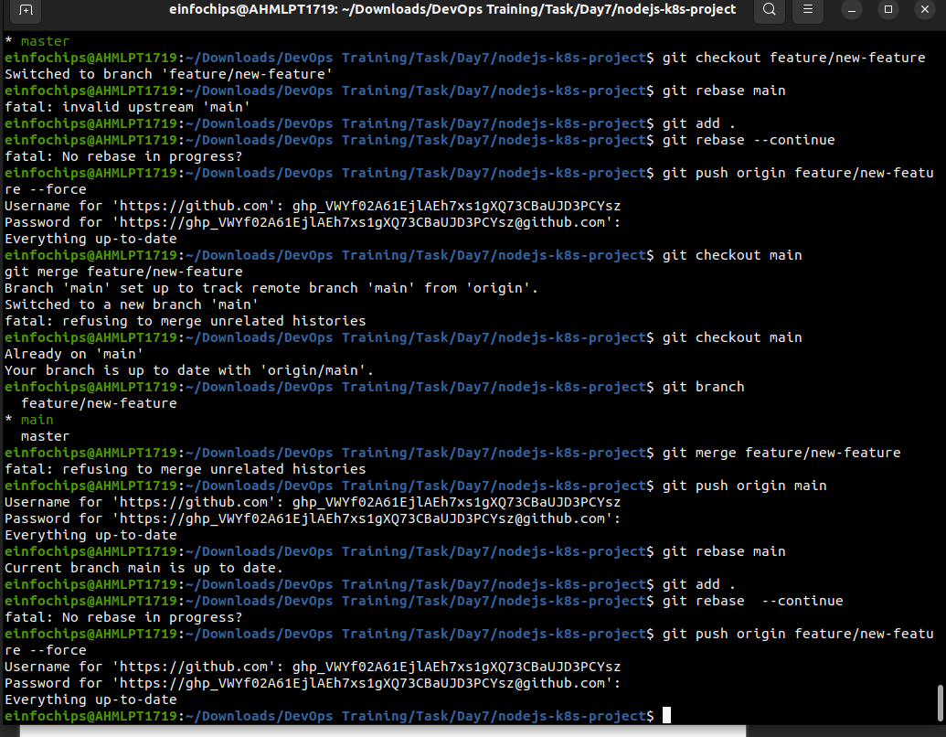

### **9. Final Commit and Cleanup**

**Merge feature branch to main**:  
  
git checkout main

git merge feature/new-feature

**Push the changes to the main branch**:  
  
git push origin main

**Clean up**:  
  
git branch -d feature/new-feature

git push origin --delete feature/new-feature

**Project 02**

Deploy a Node.js application to Kubernetes with advanced usage of ConfigMaps and Secrets. Implement Horizontal Pod Autoscaler (HPA) with both scale-up and scale-down policies. The project will include a multi-environment configuration strategy, integrating a Redis cache, and monitoring application metrics.

## **Project Setup**

### **1.1 Initialize a Git Repository**

Create a new directory for your project and initialize Git:

mkdir nodejs-advanced-k8s-project

cd nodejs-advanced-k8s-project

git init

### **1.2 Create Initial Files**

Create the initial Node.js application and Docker-related files:

npm init -y

npm install express redis body-parser

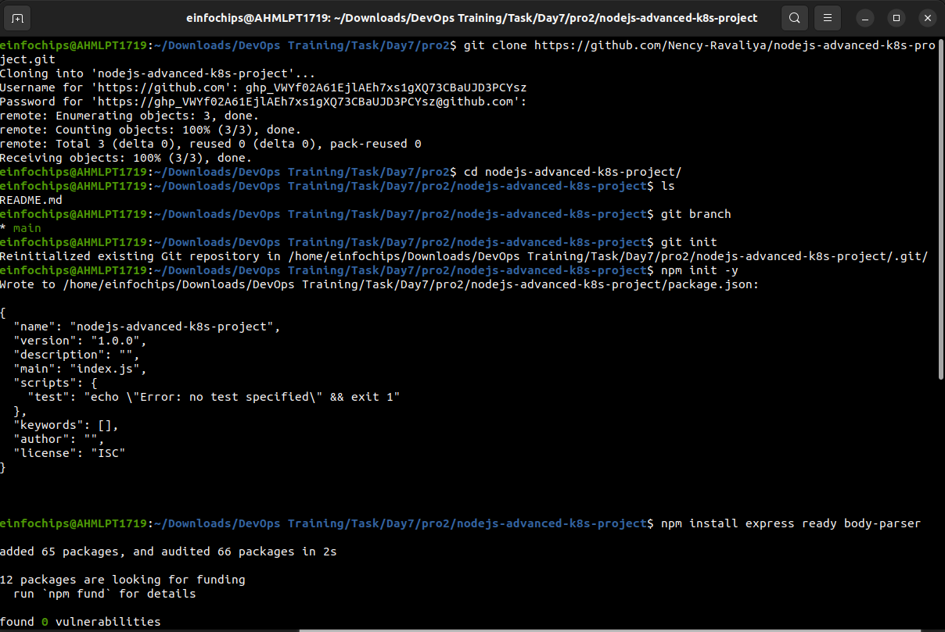

#### **app.js**

const express = require('express');

const bodyParser = require('body-parser');

const redis = require('redis');

const app = express();

const PORT = process.env.PORT || 3000;

// Connect to Redis

const redisClient = redis.create Client({

url: `redis://${process.env.REDIS_HOST}:${process.env.REDIS_PORT}`

});

redisClient.on('error', (err) => console.error('Redis Client Error', err));

app.use(bodyParser.json());

app.get('/', async (req, res) => {

const visits = await redisClient.get('visits');

if (visits) {

await redisClient.set('visits', parseInt(visits) + 1);

} else {

await redisClient.set('visits', 1);

}

res.send(`Hello, World! You are visitor number ${visits || 1}`);

});

app.listen(PORT, () => {

console.log(`Server is running on port ${PORT}`);

});

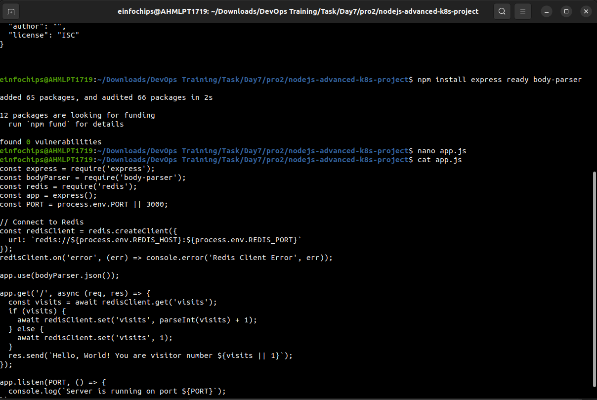

#### **Dockerfile**

FROM node:18

WORKDIR /usr/src/app

COPY package*.json ./

RUN npm install

COPY . .

EXPOSE 3000

CMD ["npm", "start"]

#### **.dockerignore**

node_modules

.npm

**1. Build and push Docker image:**

docker build -t your-dockerhub-username/nodejs-advanced-app:latest .

docker push your-dockerhub-username/nodejs-advanced-app:latest

Apply Kubernetes configurations:  
  
kubectl apply -f kubernetes/

Access the application:  
  
minikube service nodejs-advanced-app-service --url

**2. Advanced Kubernetes Configuration**

**2.1 Deployment Configuration**

Create `kubernetes/deployment.yaml` to deploy the Node.js application with Redis dependency:

```yaml

apiVersion: apps/v1

kind: Deployment

metadata:

name: nodejs-advanced-app-deployment

spec:

replicas: 2

selector:

matchLabels:

app: nodejs-advanced-app

template:

metadata:

labels:

app: nodejs-advanced-app

spec:

containers:

- name: nodejs-advanced-app

image: your-dockerhub-username/nodejs-advanced-app:latest

ports:

- containerPort: 3000

env:

- name: PORT

valueFrom:

configMapKeyRef:

name: app-config

key: PORT

- name: REDIS_HOST

valueFrom:

configMapKeyRef:

name: redis-config

key: REDIS_HOST

- name: REDIS_PORT

valueFrom:

configMapKeyRef:

name: redis-config

key: REDIS_PORT

- name: NODE_ENV

valueFrom:

secretKeyRef:

name: app-secrets

key: NODE_ENV

- name: redis

image: redis:latest

ports:

- containerPort: 6379

### **2.2 ConfigMap for Application and Redis**

Create kubernetes/configmap.yaml to manage application and Redis configurations:

apiVersion: v1

kind: ConfigMap

metadata:

name: app-config

data:

PORT: "3000"

---

apiVersion: v1

kind: ConfigMap

metadata:

name: redis-config

data:

REDIS_HOST: "redis"

REDIS_PORT: "6379"

### **2.3 Secret for Sensitive Data**

Create kubernetes/secret.yaml to manage sensitive environment variables:

apiVersion: v1

kind: Secret

metadata:

name: app-secrets

type: Opaque

data:

NODE_ENV: cHJvZHVjdGlvbg== # Base64 encoded value for "production"

### **2.4 Service Configuration**

Create kubernetes/service.yaml to expose the Node.js application:

apiVersion: v1

kind: Service

metadata:

name: nodejs-advanced-app-service

spec:

selector:

app: nodejs-advanced-app

ports:

- protocol: TCP

port: 80

targetPort: 3000

type: LoadBalancer

### **2.5 Horizontal Pod Autoscaler with Scale-Up and Scale-Down Policies**

Create kubernetes/hpa.yaml to manage autoscaling:

apiVersion: autoscaling/v2beta2

kind: HorizontalPodAutoscaler

metadata:

name: nodejs-advanced-app-hpa

spec:

scaleTargetRef:

apiVersion: apps/v1

kind: Deployment

name: nodejs-advanced-app-deployment

minReplicas: 2

maxReplicas: 5

metrics:

- type: Resource

resource:

name: cpu

target:

type: Utilization

averageUtilization: 50

- type: Resource

resource:

name: memory

target:

type: Utilization

averageUtilization: 70

behavior:

scaleUp:

stabilizationWindowSeconds: 30

selectPolicy: Max

policies:

- type: Pods

value: 2

periodSeconds: 30

- type: Resource

resource: cpu

value: 2

periodSeconds: 30

scaleDown:

stabilizationWindowSeconds: 30

selectPolicy: Min

policies:

- type: Pods

value: 1

periodSeconds: 30

- type: Resource

resource: memory

value: 1

periodSeconds: 30

### **2.6 Vertical Pod Autoscaler Configuration**

Create kubernetes/vpa.yaml to manage vertical scaling:

apiVersion: autoscaling.k8s.io/v1beta2

kind: VerticalPodAutoscaler

metadata:

name: nodejs-advanced-app-vpa

spec:

targetRef:

apiVersion: apps/v1

kind: Deployment

name: nodejs-advanced-app-deployment

updatePolicy:

updateMode: "Auto"

### **2.7 Redis Deployment**

Add a Redis deployment configuration to kubernetes/redis-deployment.yaml:

apiVersion: apps/v1

kind: Deployment

metadata:

name: redis-deployment

spec:

replicas: 1

selector:

matchLabels:

app: redis

template:

metadata:

labels:

app: redis

spec:

containers:

- name: redis

image: redis:latest

ports:

- containerPort: 6379

Add Redis service configuration to kubernetes/redis-service.yaml:

apiVersion: v1

kind: Service

metadata:

name: redis-service

spec:

selector:

app: redis

ports:

- protocol: TCP

port: 6379

targetPort: 6379

type: ClusterIP

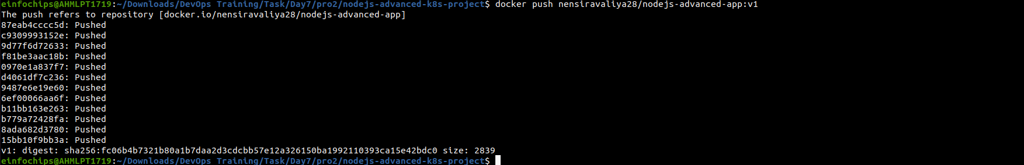

### **2.8 Apply Kubernetes Configurations**

Apply all configurations to your Minikube cluster:

kubectl apply -f kubernetes/redis-deployment.yaml

kubectl apply -f kubernetes/redis-service.yaml

kubectl apply -f kubernetes/configmap.yaml

kubectl apply -f kubernetes/secret.yaml

kubectl apply -f kubernetes/deployment.yaml

kubectl apply -f kubernetes/service.yaml

kubectl apply -f kubernetes/hpa.yaml

kubectl apply -f kubernetes/vpa.yaml

### **2.9 Verify Deployments and Services**

Check the status of your deployments and services:

kubectl get all

Access the application via Minikube:

minikube service nodejs-advanced-app-service –url

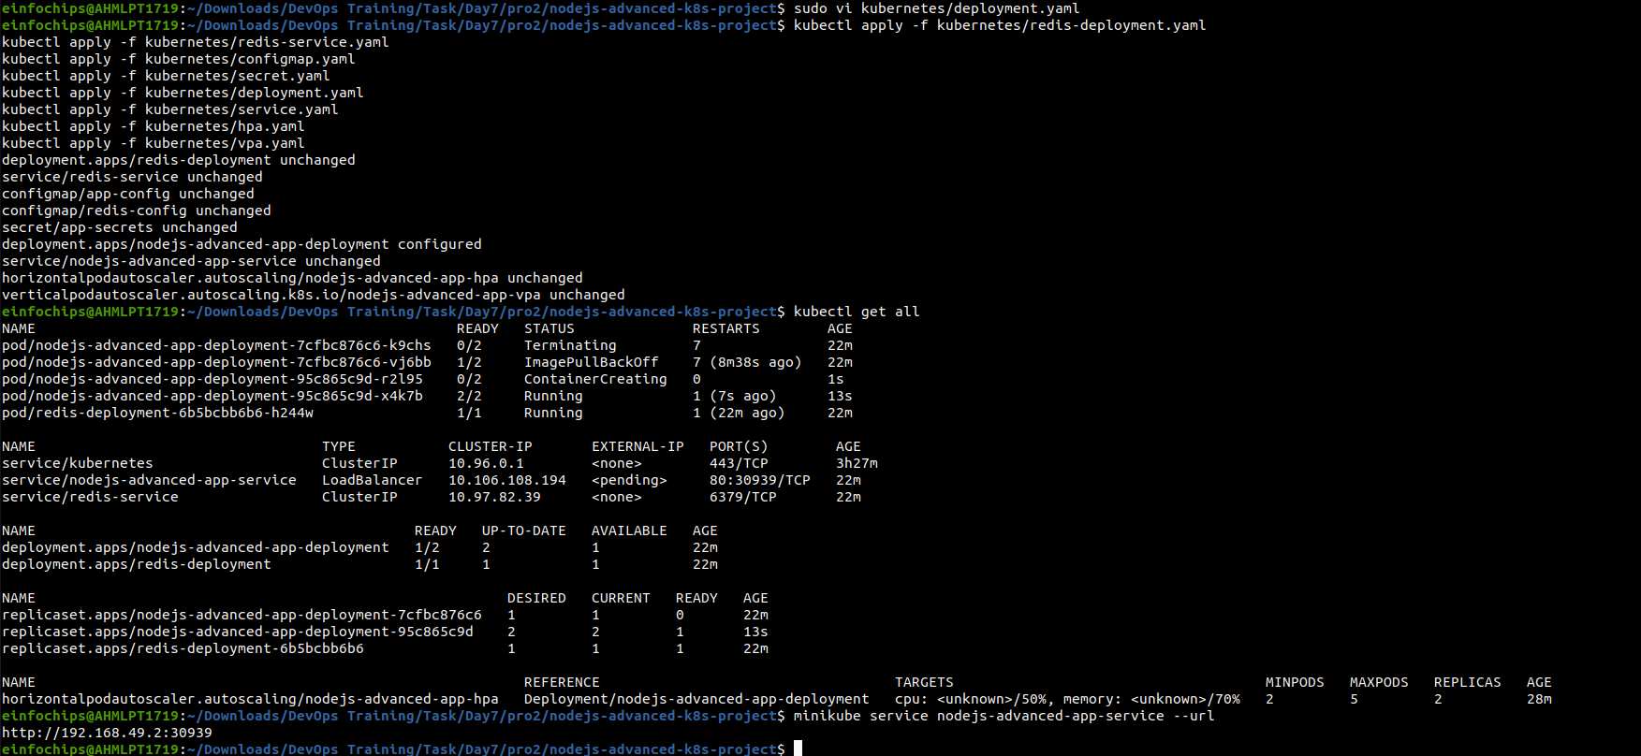

### **2.10 Testing Scaling**

Simulate load on the application to test the HPA:

kubectl run -i --tty --rm load-generator --image=busybox --restart=Never -- /bin/sh

# Inside the pod, run the following command to generate load

while true; do wget -q -O- http://nodejs-advanced-app-service; done

### **2.11 Validate Autoscaling Behavior**

Observe the HPA behavior:

kubectl get hpa

Watch the scaling events and verify that the application scales up and down based on the policies you configured.

## **3. Project Wrap-Up**

### **3.1 Review and Clean Up**

After completing the project, review the configurations and clean up the Minikube environment if needed:

minikube delete